Group Project Documentation   
Advanced Cross-Platform Application Programming with .NET

*<Cat Coffee Platform>*

**Prepared by <9999>**

***<Phạm Hữu Trí***

***Đặng Thanh Long***

***Nguyễn Trung Tín***

***Lâm Trần Như Ngọ>***

**Ho Chi Minh City, 2024**

**Table of Contents**

**Table of Contents ii**

**Revision History ii**

**1.** **Project Introduction 1**

1.1 Product Perspective 1

1.2 User Classes and Characteristics 1

**2.** **Database Design 1**

**3.** **System Architecture 1**

**4.** **Implementation 2**

4.1. Deployment Considerations 2

4.2. Screenshots and explanations 2

**5.** **References 2**

**Revision History**

|  |  |  |  |
| --- | --- | --- | --- |
| **Name** | **Date** | **Reason For Changes** | **Version** |
| *Van Vo* | *01 January 2024* | *Initial draft* | *1.0 draft 1* |
|  |  |  |  |
|  |  |  |  |
|  |  |  |  |

# Project Introduction

## Product Perspective

*Cat cafe is currently emerging as a new form of business that attracts many young people. The above cafes bring us. Currently, cat cafes often provide users with combined services from cats and coffee, they will create for you an environment where you can relax with your cup of coffee while playing with cats. . But finding cat cafes is still a barrier for cat lovers because of the small number of this type of entertainment. Therefore, the Cat Cafe platform was born to help cat-loving customers find what they want as well as support cat cafe shops to promote this type of business more widely.*

## User Classes and Characteristics

*It is crucial to identify the different user groups (user classes) who will interact with the Cat Cafe Platform and understand their characteristics. This information is essential for tailoring the platform's features and ensuring it caters to the needs of each user class effectively.*

*Cat Lovers (Customers):*

*Characteristics:*

*Individuals who enjoy spending time with cats and appreciate the calming and therapeutic effects of their presence.*

*May be familiar with cat cafes or be new to the concept.*

*Tech-savvy and comfortable using online platforms for booking and information access.*

*Age range varies, but likely skews younger due to the popularity of cat cafes among millennials and Gen Z.*

*Cat Cafe Owners/Managers:*

*Characteristics:*

*Individuals responsible for operating and managing cat cafes.*

*Interested in attracting new customers and streamlining their business operations.*

*Possess basic to moderate technical skills for managing online listings and bookings.*

*Primarily focused on cafes specializing in providing cat interaction experiences alongside food and beverage offerings.*

# Database Design

## Use Case Diagram

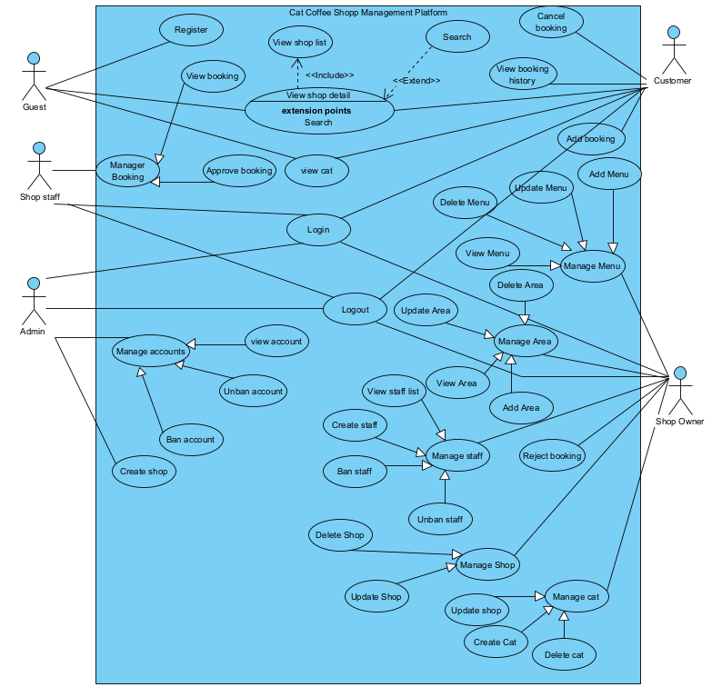

## **Class** Diagram

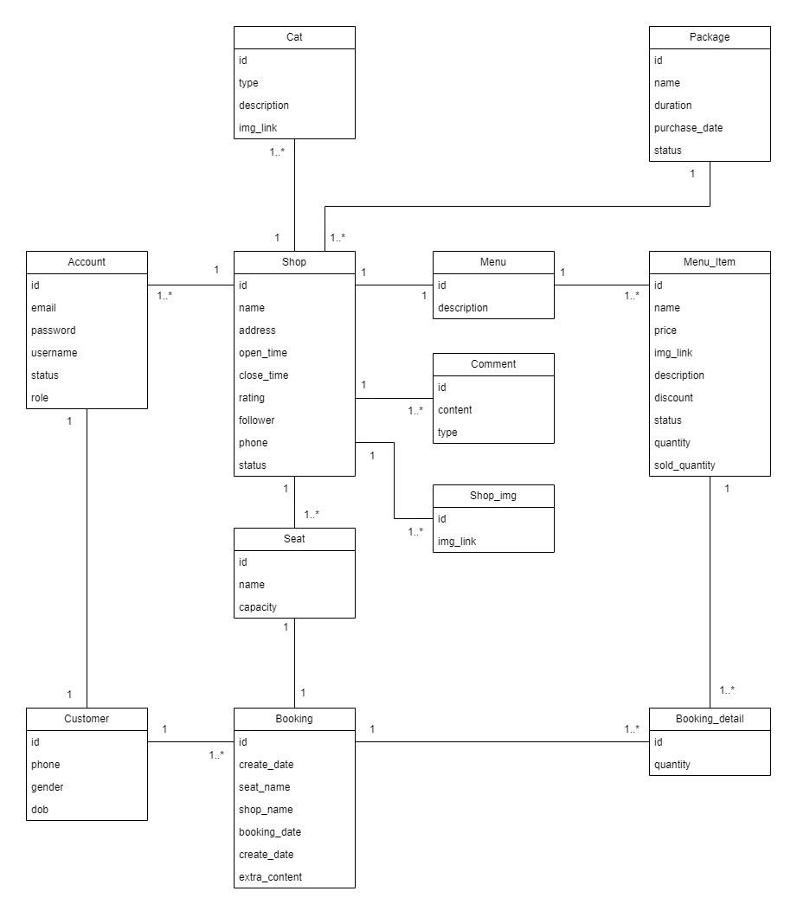

## **Database** Diagram

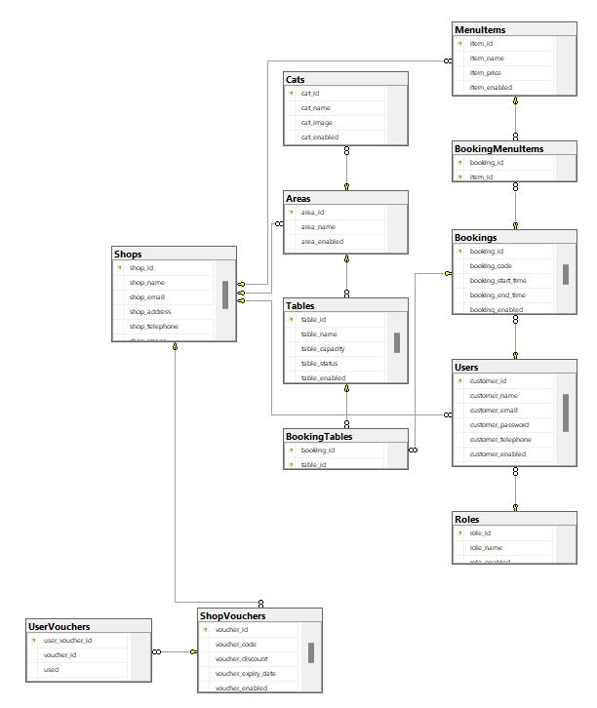

## **Database Schema Diagram**

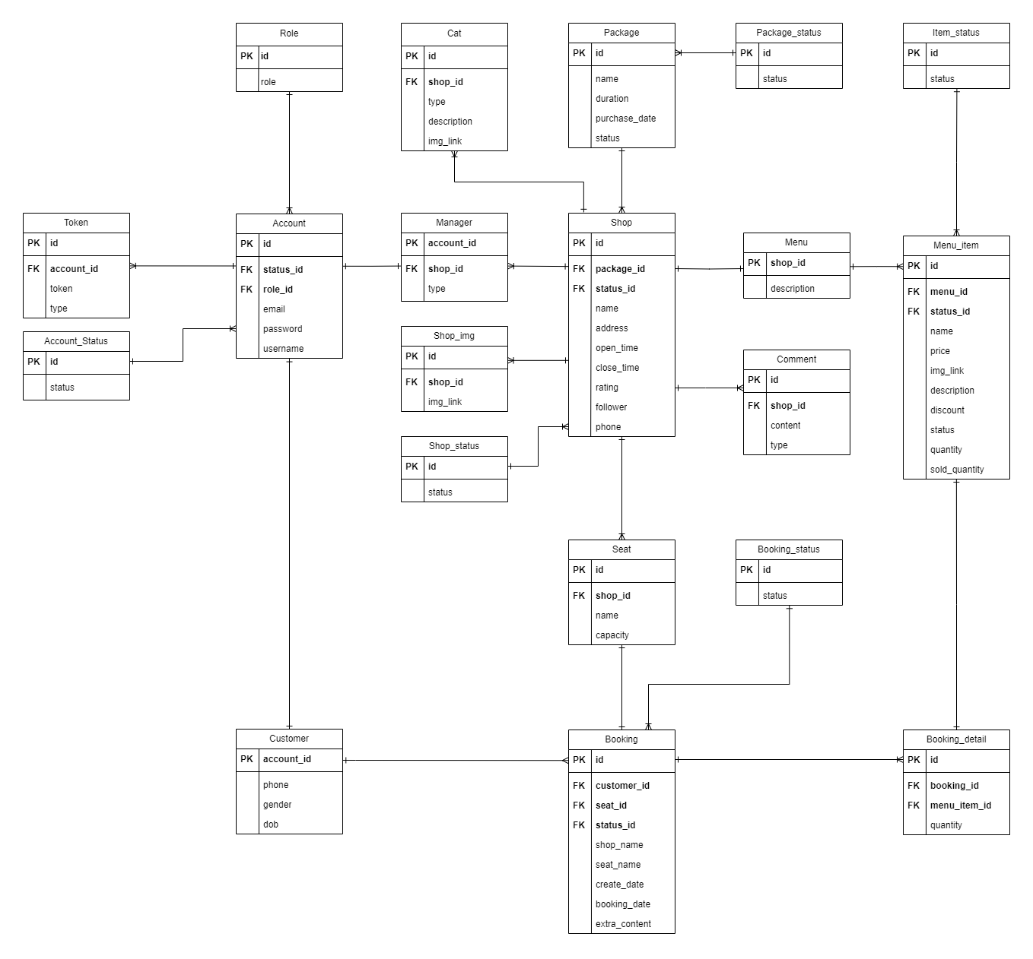

## **Entity Relationship Diagram**

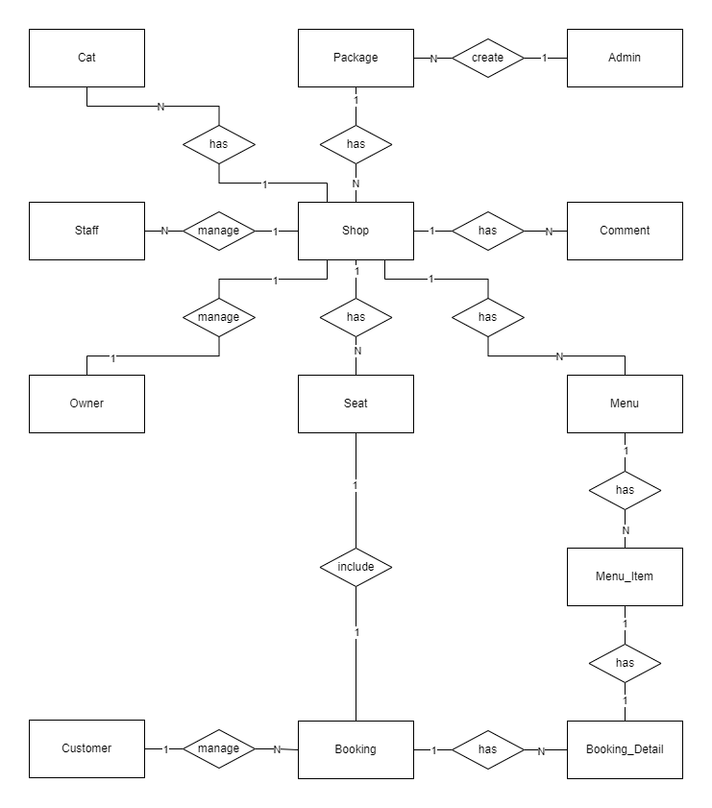

# System Architecture

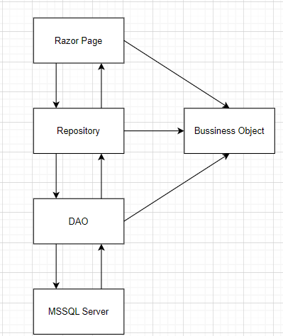

***Environment:***

*Hardware platform: The system can operate on personal computers*

*Operating system: The system can operate on Windows*

*Web browser: The system can work on web browsers Chrome*

***System design:***

*Architecture: The system will be designed according to a distributed architecture with the following components:*

*User Interface: The user interface will be designed to be simple, easy to use and user-friendly. The user interface will be developed using HTML*

*Application server: The application server will handle requests from the user interface and access the database. The application server will be developed in C#.*

*Database: The database will store all the system's data. The database can use MySQL*

*Programming: The system will be programmed in popular programming languages such as C#.*

*Scalability: The system will be designed to be easily scalable when needed.*

***Technology used:***

Visual Studio 2022(Razor Page), MSSQL Server

# Implementation

## Deployment Considerations

***User Access and Location:***

*User distribution: Users cannot be geographically dispersed, cannot be in many different time zones.*

*Access Needs: Users will require consistent and reliable access to the platform throughout its life*

*Change training and business processes:*

*Training materials should be prepared for both cat cafe owners and users to familiarize them with the features and functions of the platform.*

*The cat cafe's business processes may need to be adjusted to integrate with the online booking system and manage interactions through the platform.*

***Infrastructure Considerations:***

*Scalability: The platform's infrastructure must be scalable to accommodate potential growth in user base and data volume. This may involve using cloud-based solutions or having the ability to easily add resources as needed.*

*Network access: A secure and reliable network connection is important for both users and cafes to access the platform seamlessly.*

*Data storage: A robust and secure data storage solution (e.g. cloud-based database) is required to store user information, cafe data, reservations.*

*Data Migration: If transferring data from existing systems, a clearly defined migration plan is needed to ensure data integrity and minimize disruption.*

***Deployment Activities:***

*Testing: Thorough testing in a non-production environment is essential before deploying the platform publicly.*

*Phased rollout: Consider a phased rollout approach, starting with a limited group of users and cafes to identify and resolve any potential issues before rolling out more broadly.*

*Monitoring and support: Closely monitor system performance after implementation and provide full support to users and cafes during the transition.*

## Screenshots and explanations

**4.2.1 Booking**

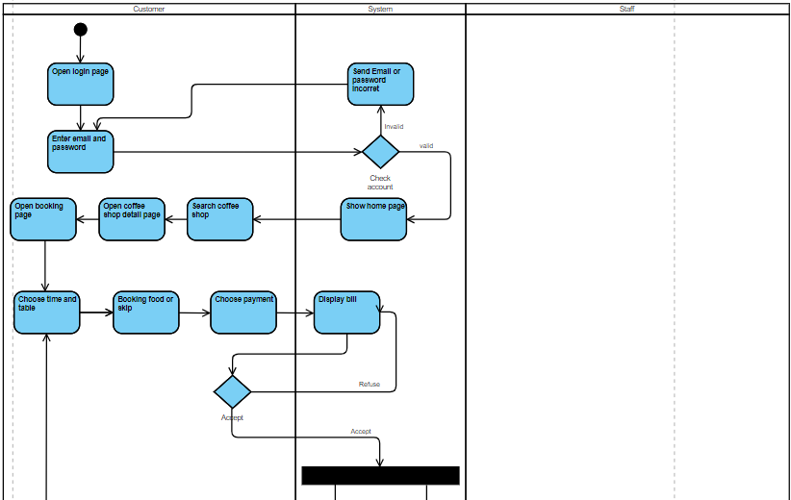

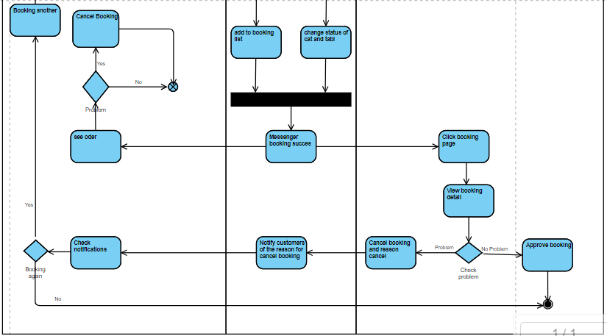

**4.2.2 Manager account and package**

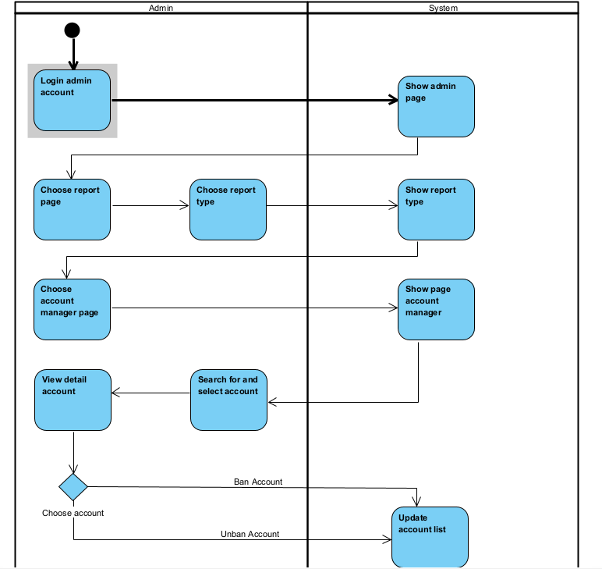

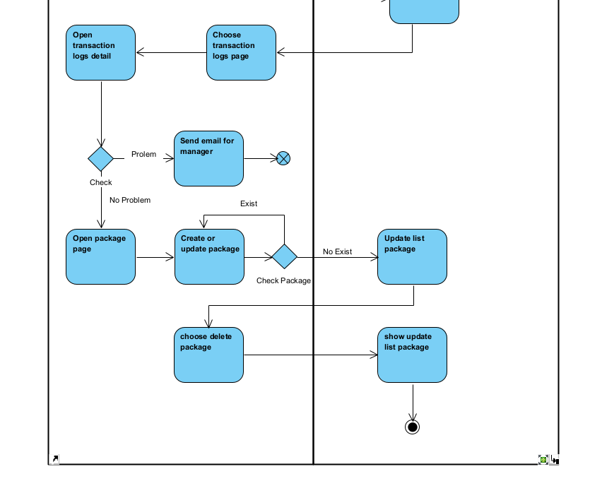

**4.2.3 Manager account staff**

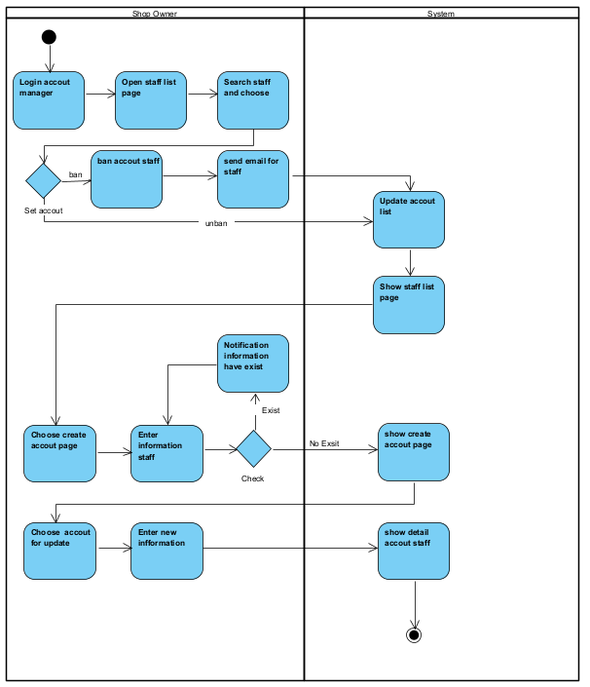

**4.2.4 Manager shop**

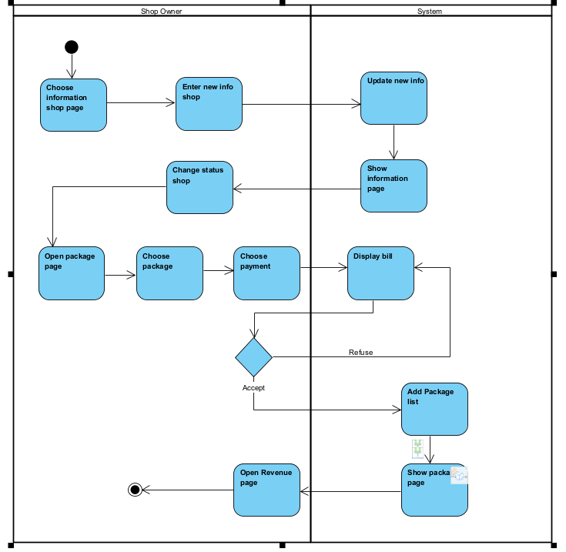

**4.2.5 Manager cat and food**

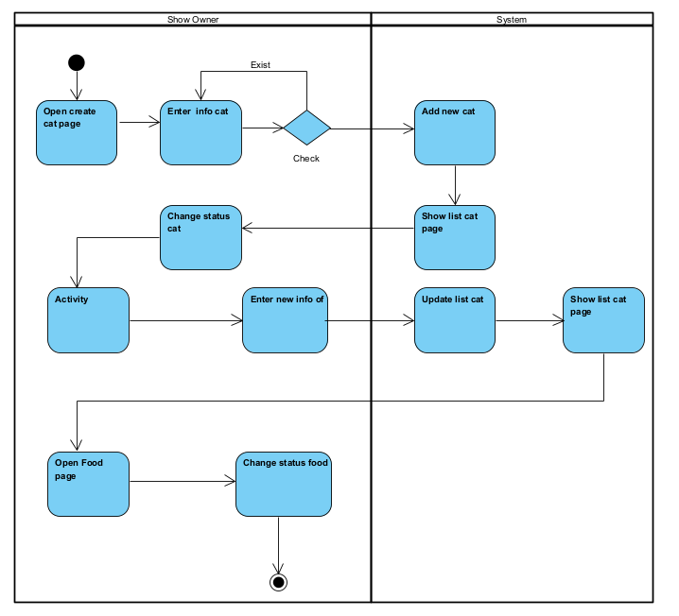

*<The screenshots and explanations>*

# References

1. *<https://www.foody.vn/ho-chi-minh/catfe-coffee>*
2. *<https://www.coffeecatscafe.com/>*
3. *<https://www.catfe.vn/>*
4. *<https://catcafe.co.uk/>*